**MIDDLETON CHENEY FOOTBALL CLUB**

**ANNUAL GENERAL MEETING**

**1983**

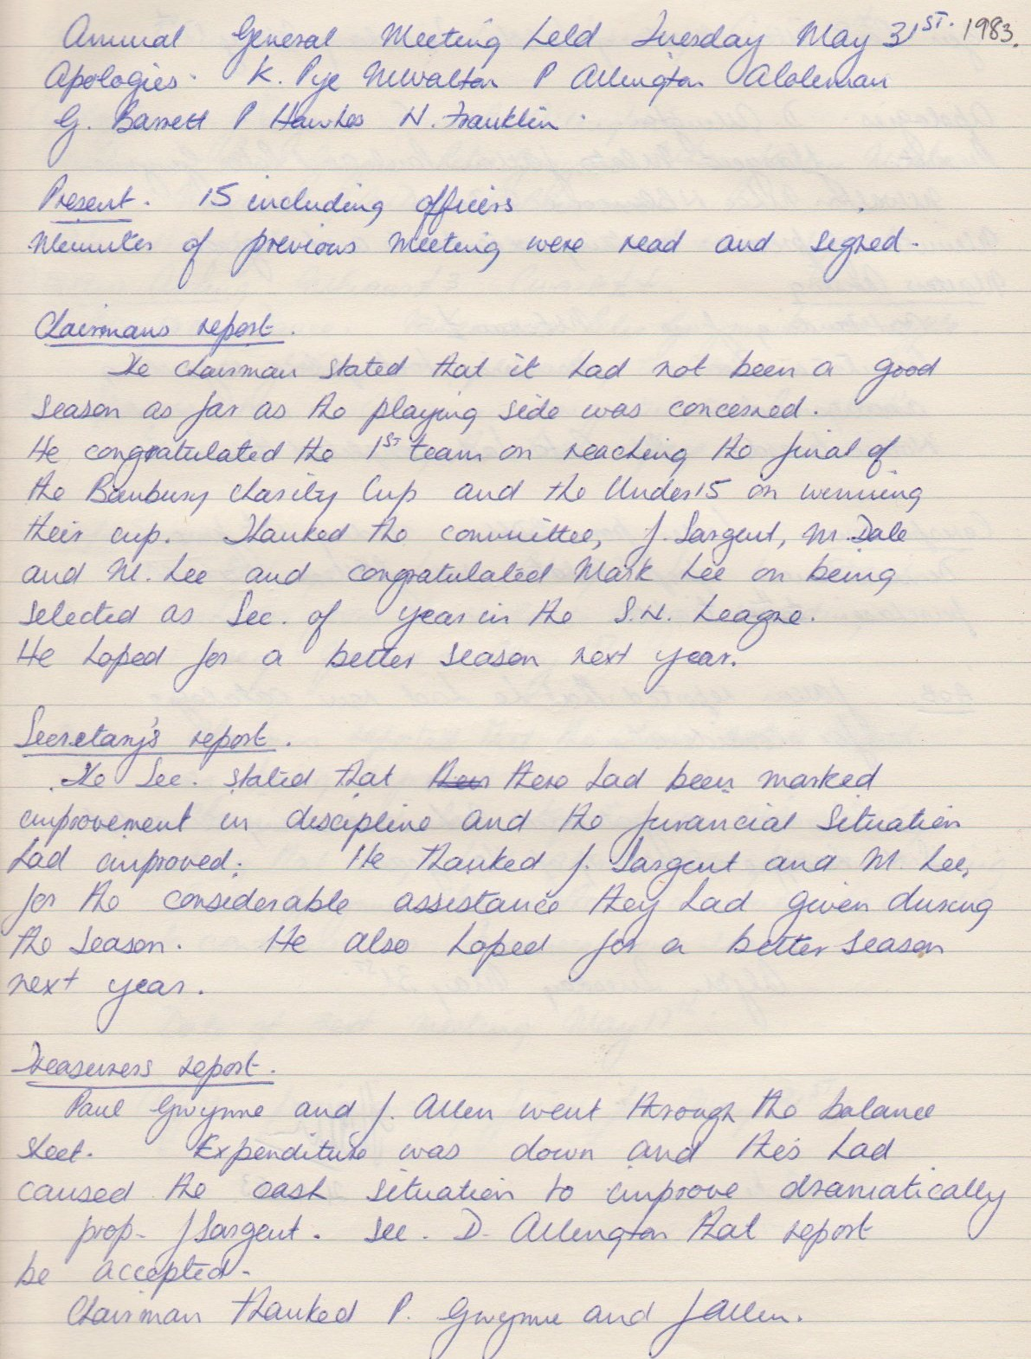

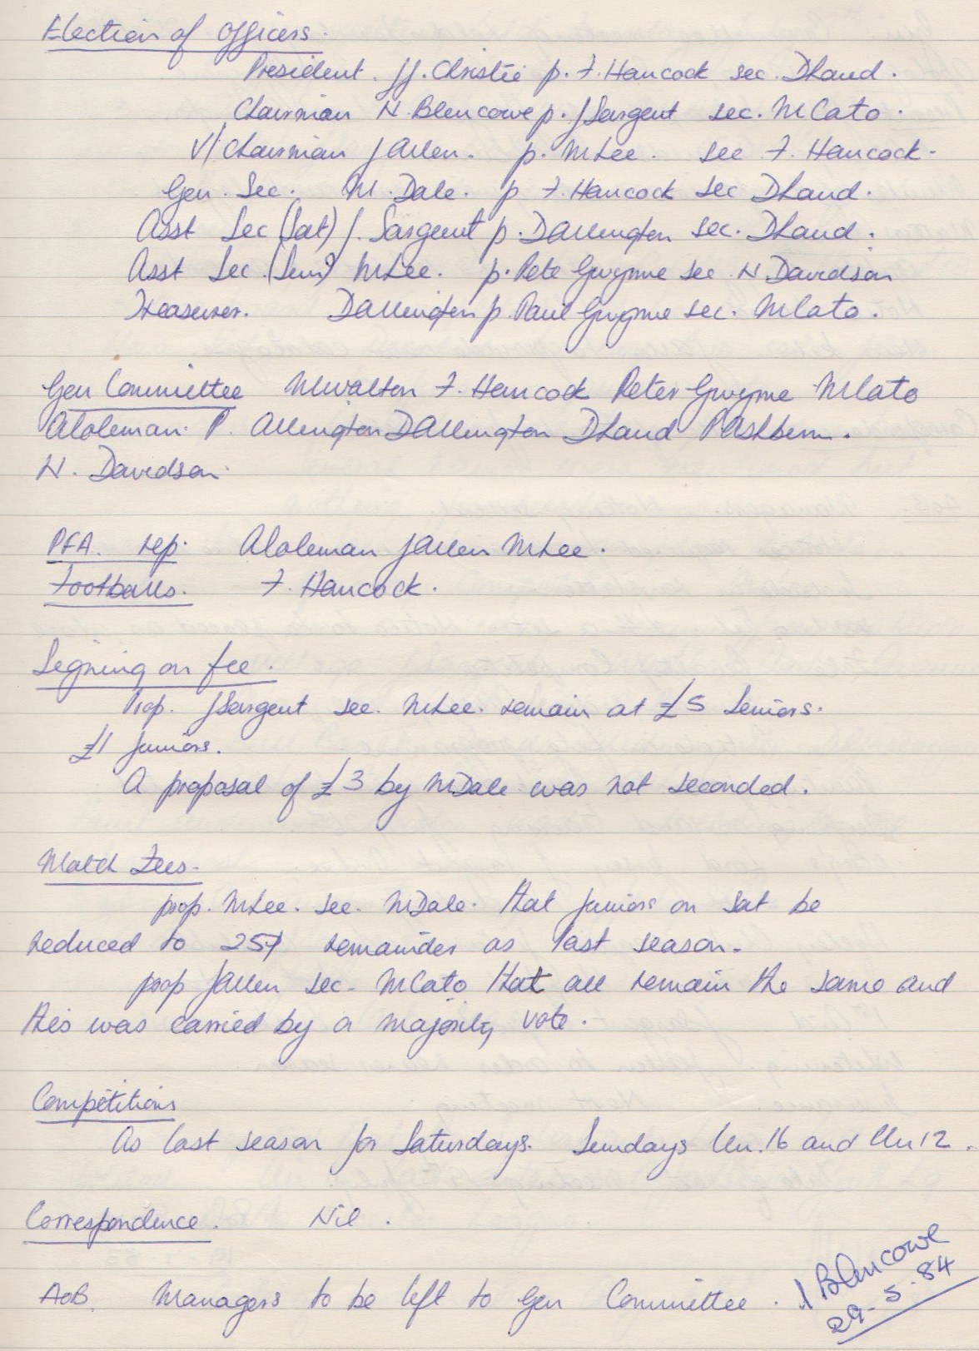

**General Committee Meeting**

**June 21st 1983**

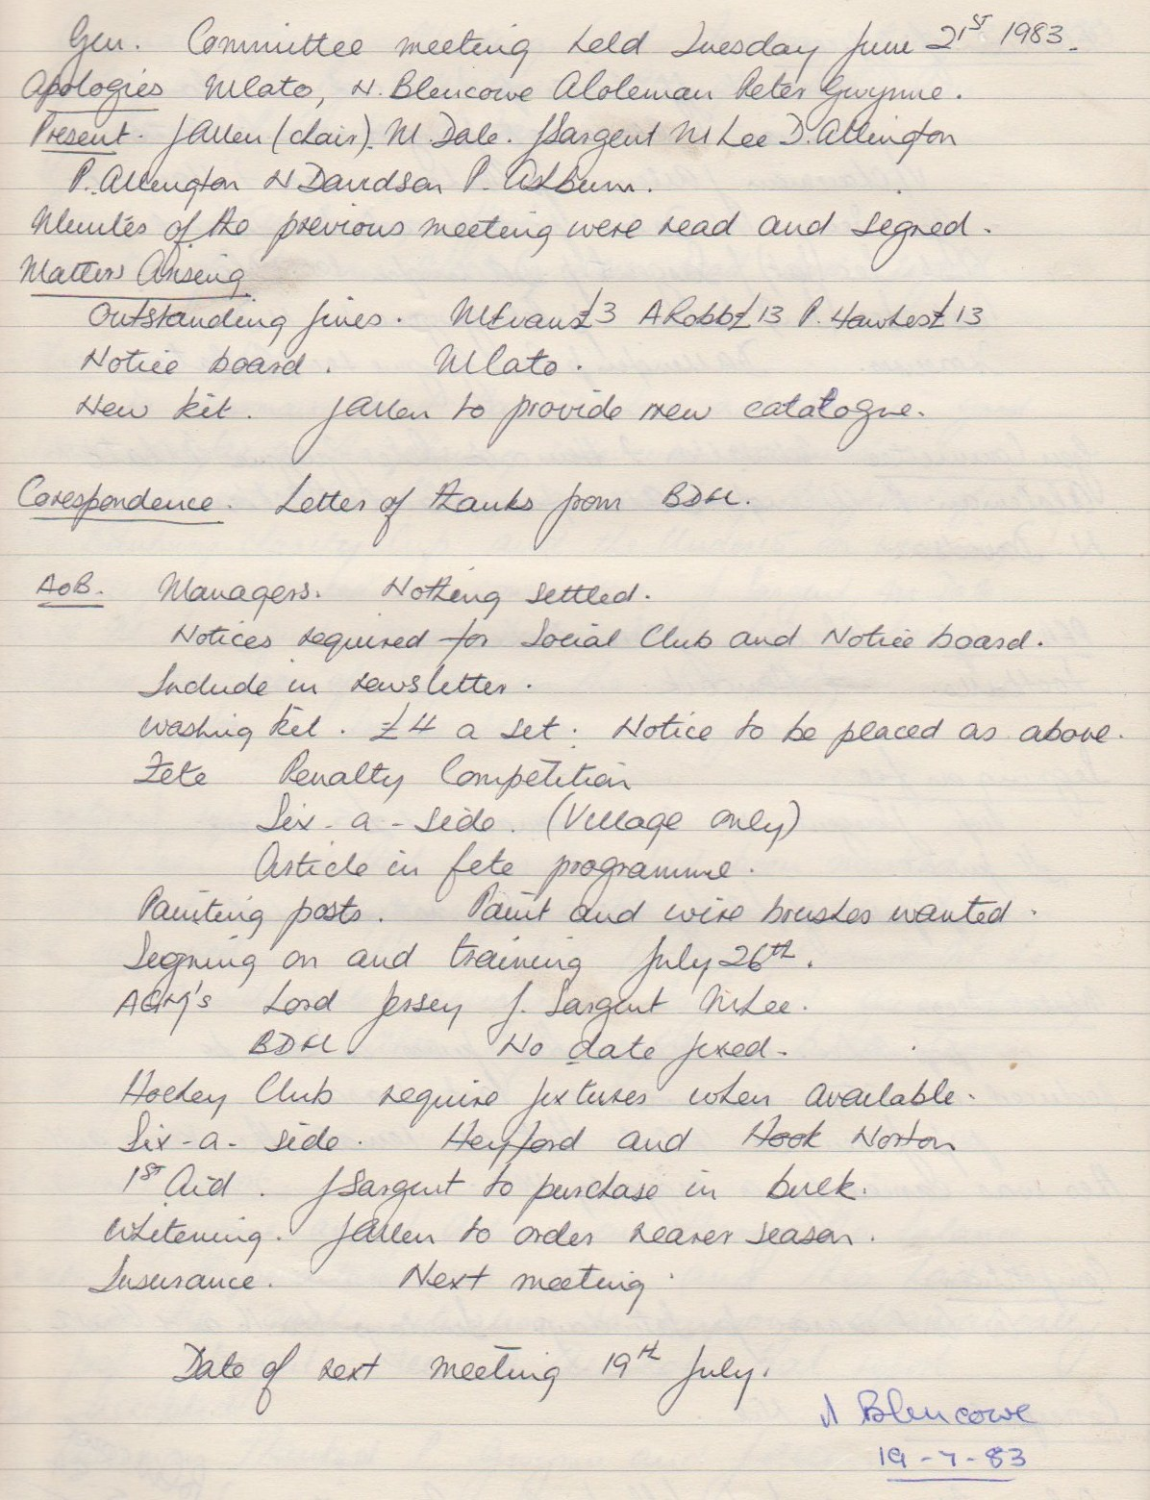

**General Committee Meeting**

**July 19th 1983**

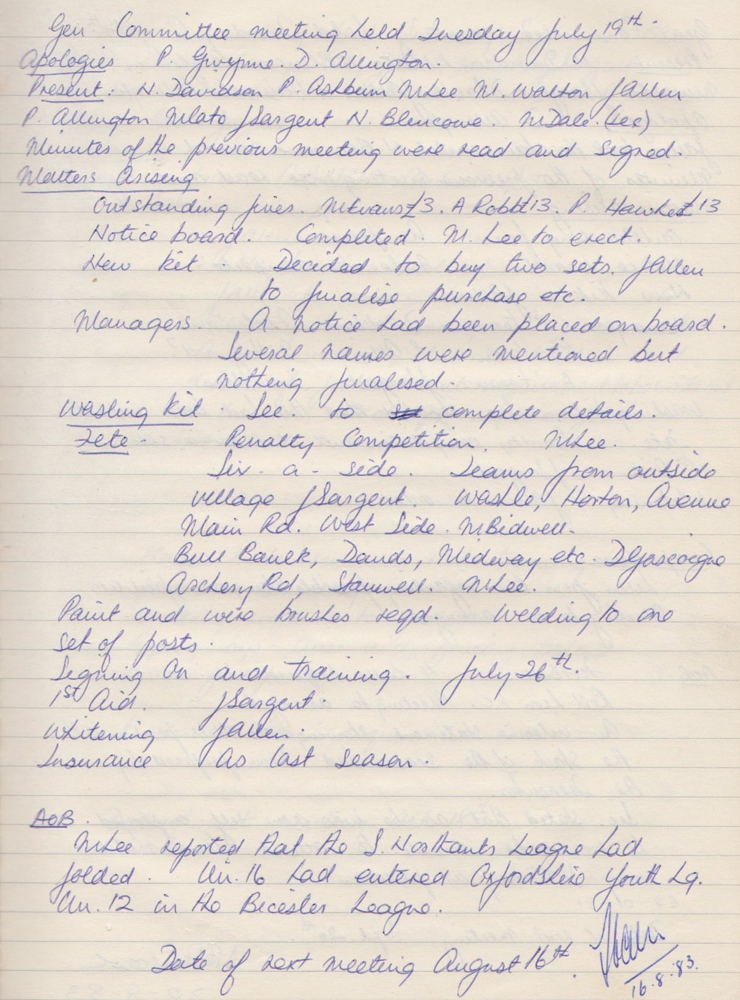

**General Committee Meeting**

**August 16th 1983**

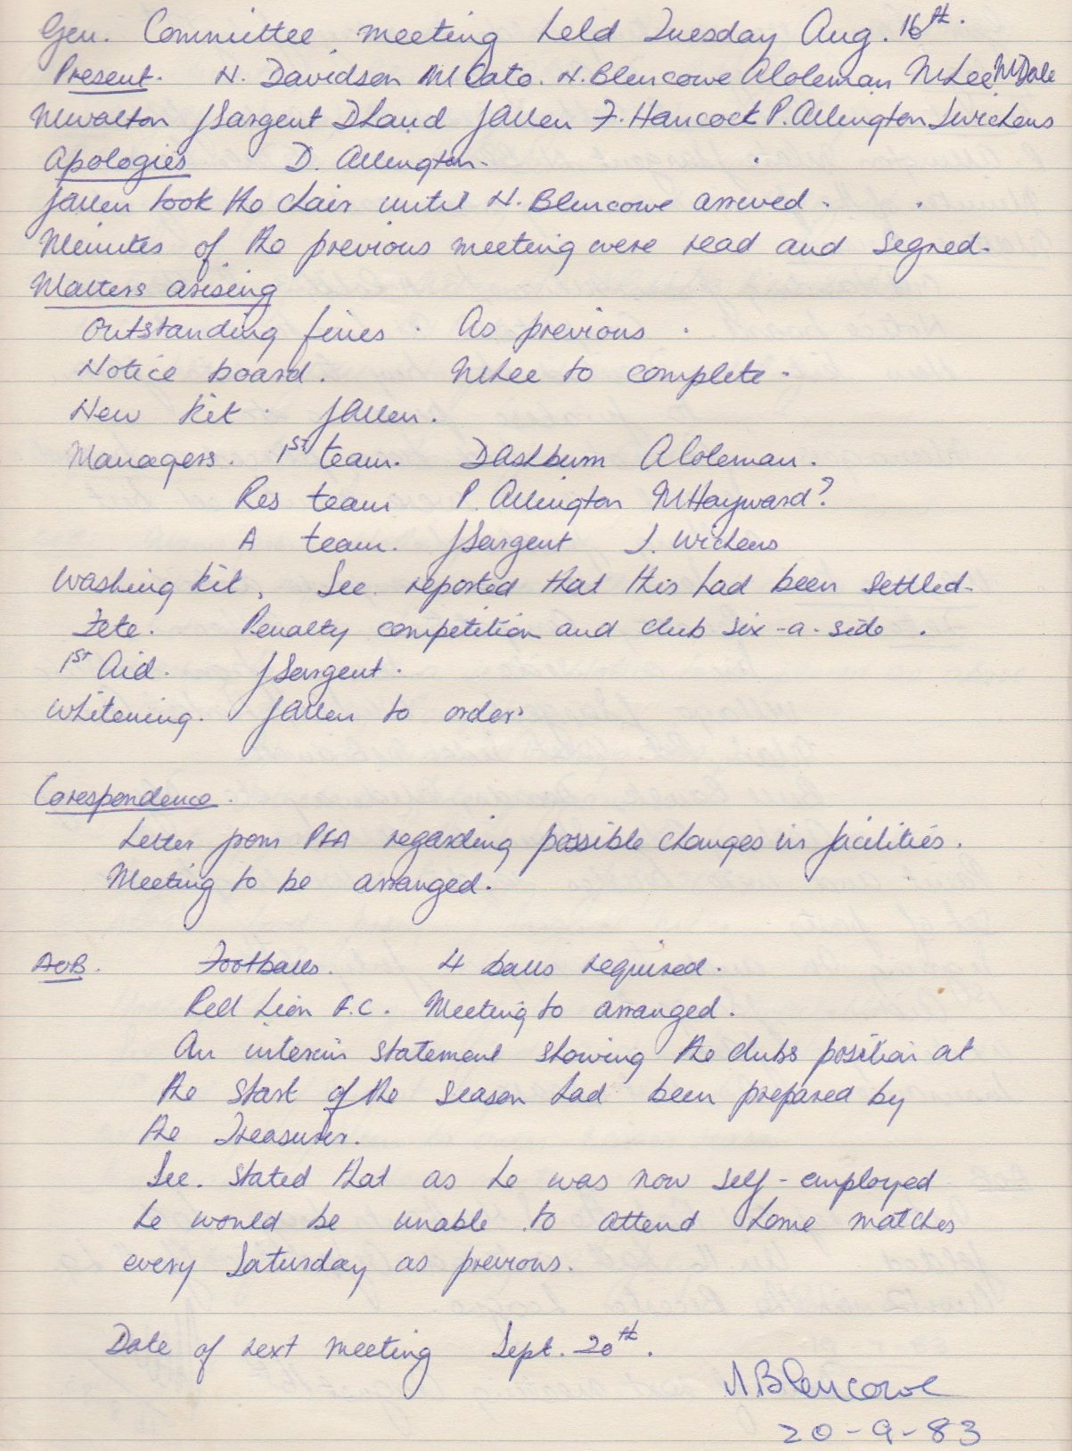

**General Committee Meeting**

**September 20th 1983**

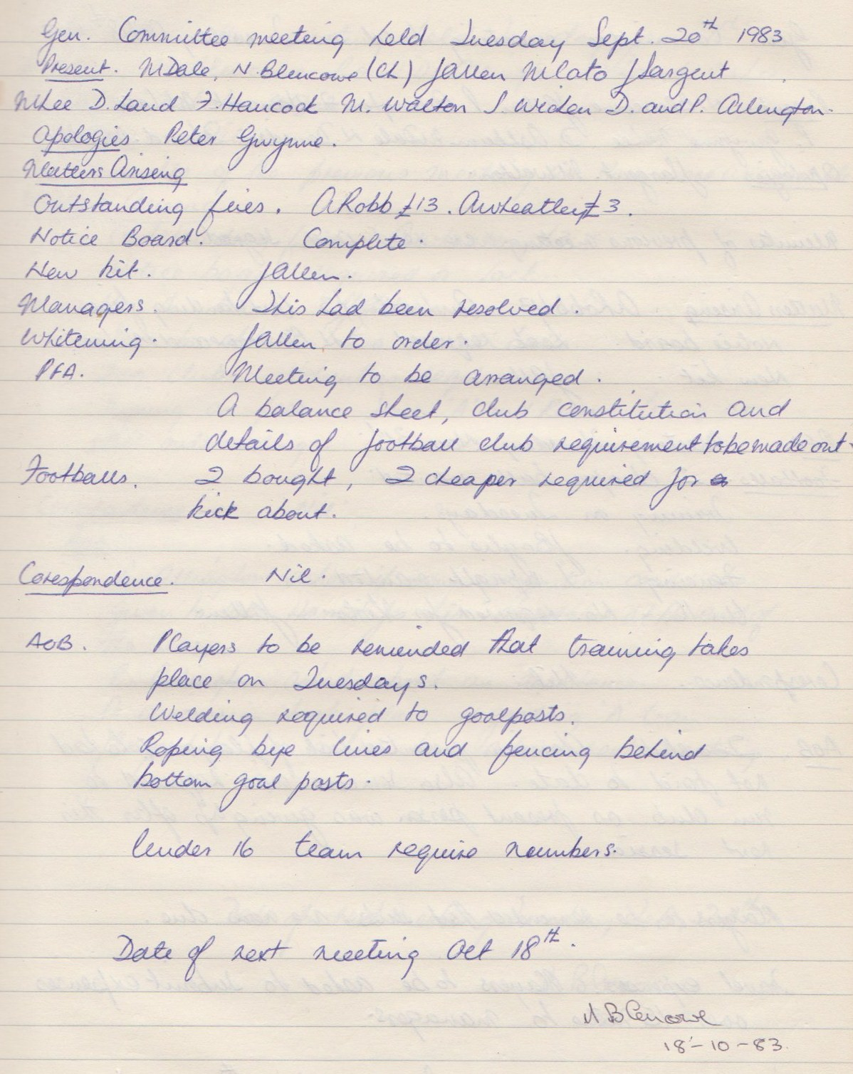

**General Committee Meeting**

**October 18th 1983**

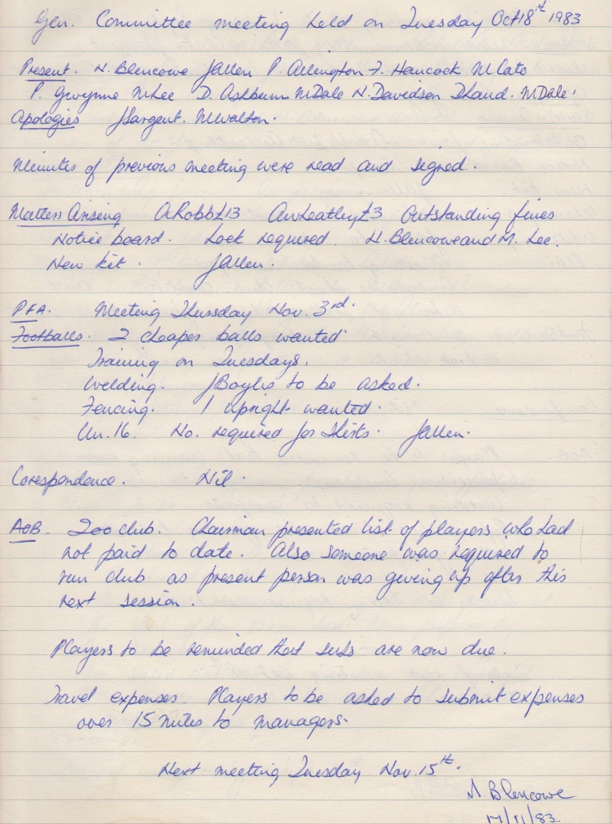

**General Committee Meeting**

**January 17th 1984**

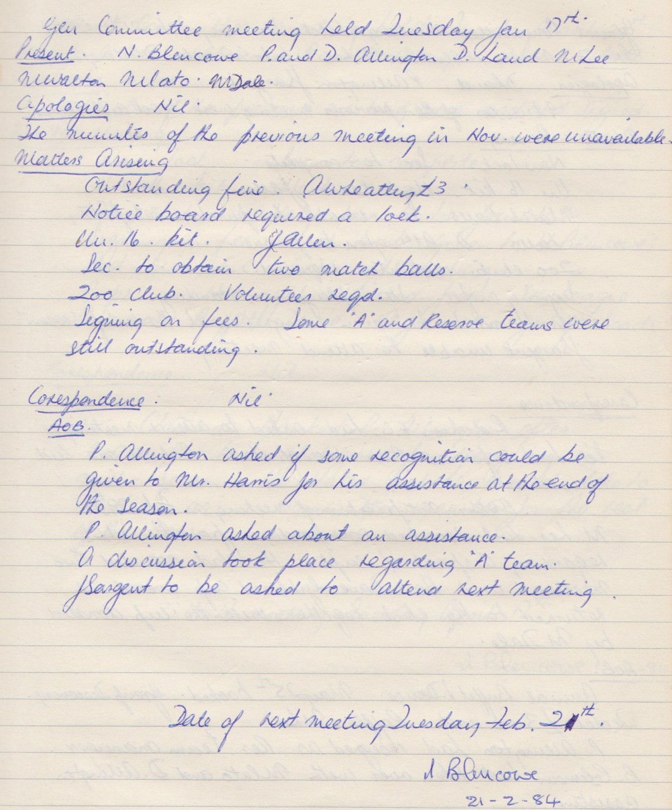

**General Committee Meeting**

**February 21st 1984**

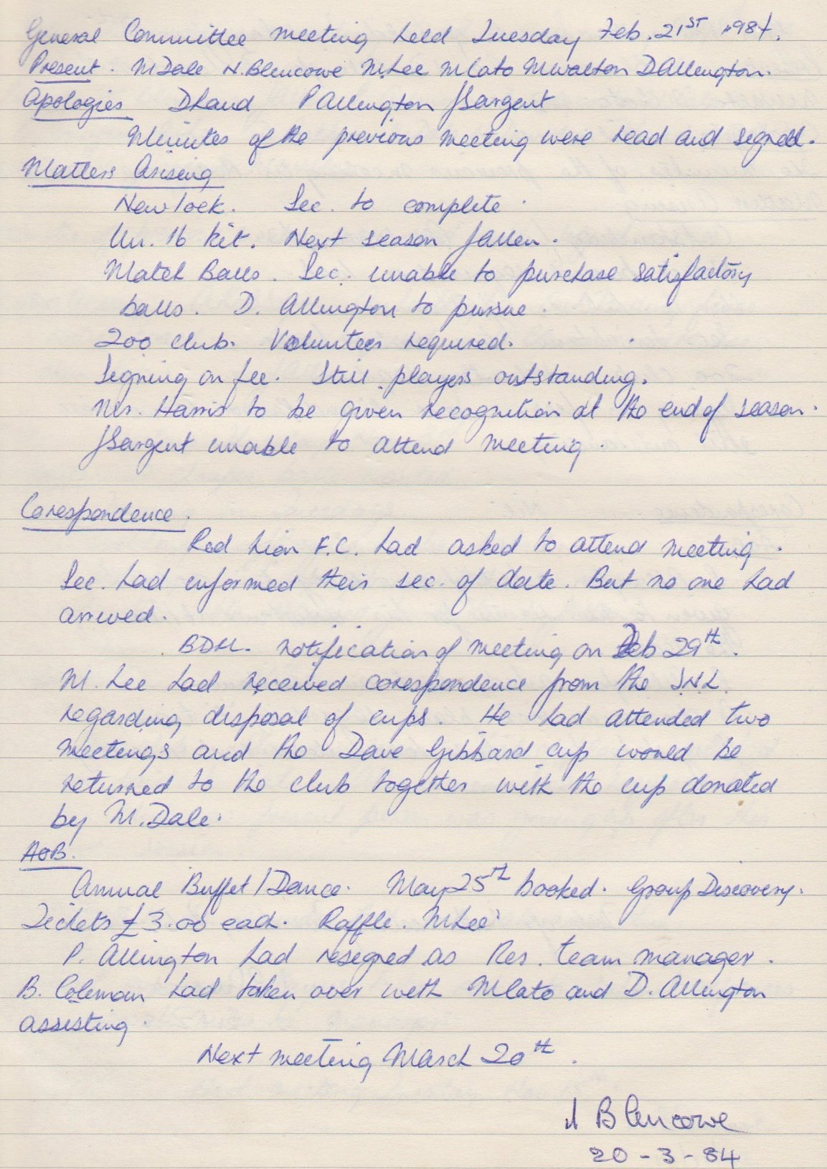

**General Committee Meeting**

**March 20th 1984**

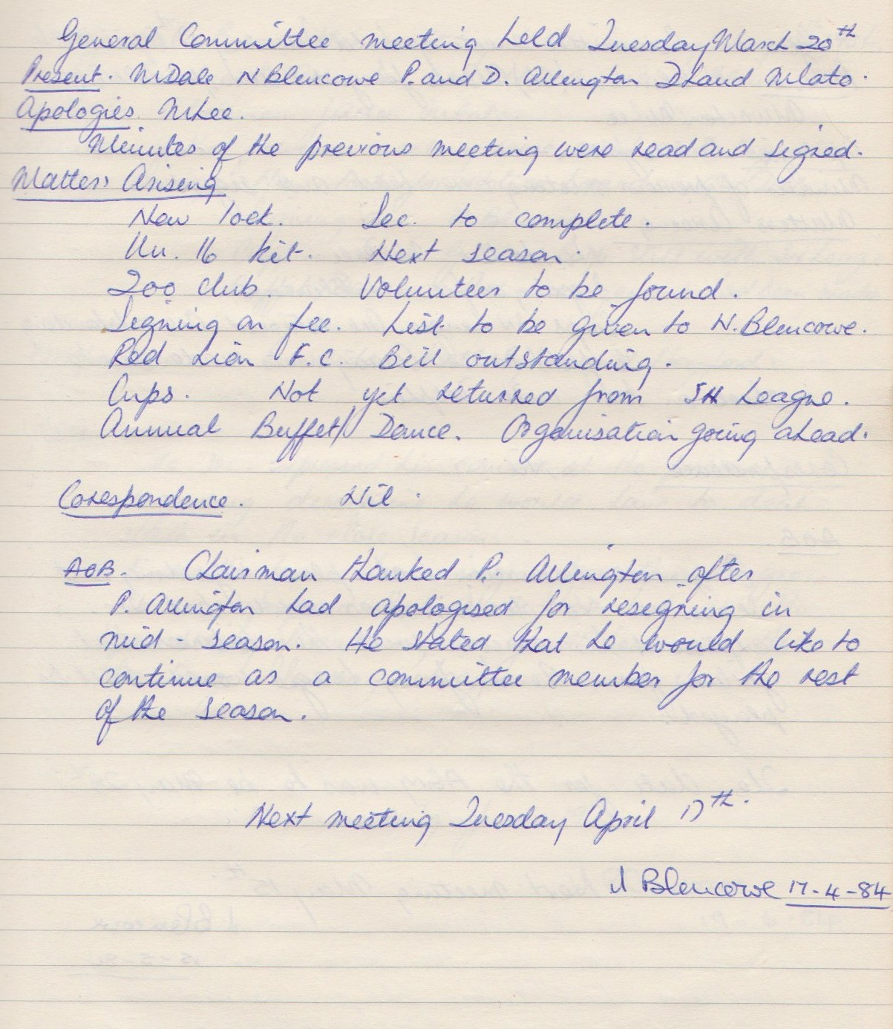

**General Committee Meeting**

**April 17th 1984**

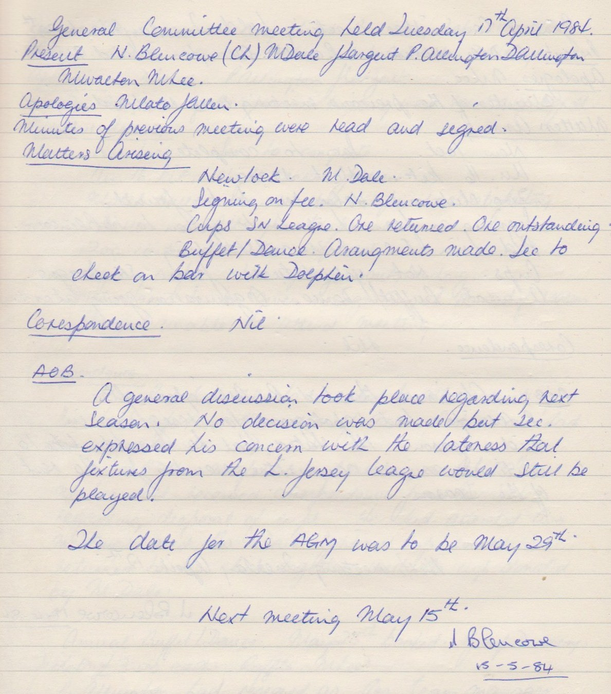

**General Committee Meeting**

**May 15th 1984**

